SUPER MARIO GAME DEPLOYMENT
(AWS DEVOPS PROJECT)
Prerequisite →
- We will use AWS account .
- Then we configure Terraform inside an ec2 instance
- we also need an IAM ec2 role that provide necessary permission to ec2
Completion steps →
Step 1 → Login and basics setup
Step 2 → Setup Docker ,Terraform ,aws cli , and Kubectl
Step 3 → IAM Role for EC2
Step 4 →Attach IAM role with your EC2
Step 5 → Building Infrastructure Using terraform
Step 6 → Creation of deployment and service for EKS
Step 7 → Destroy all the Insrastructure

Steps:

Step 1 : First we will Launch EC2 machine
Go to aws account
Go to Instances ->Launch instance

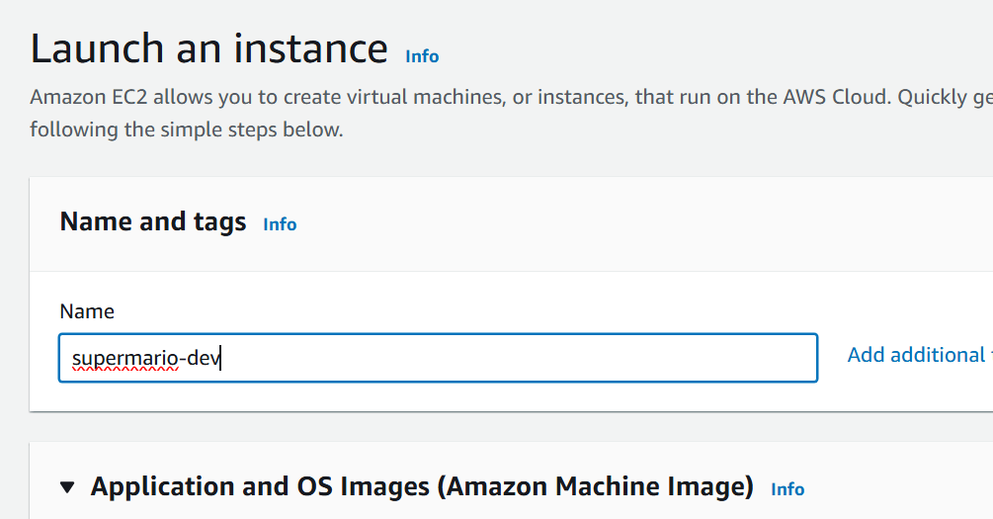

Use AMI as ubuntu
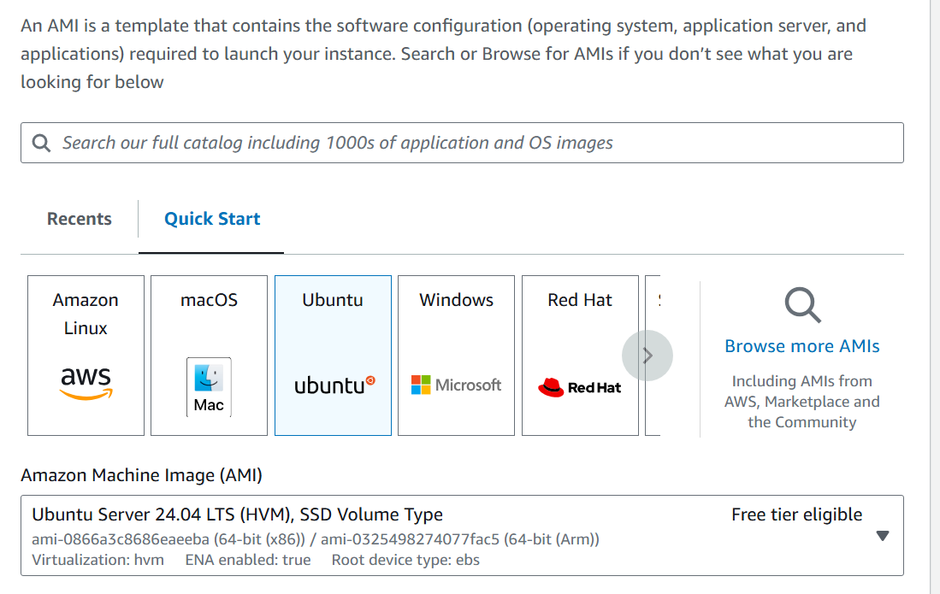

Instance type : T3.medium
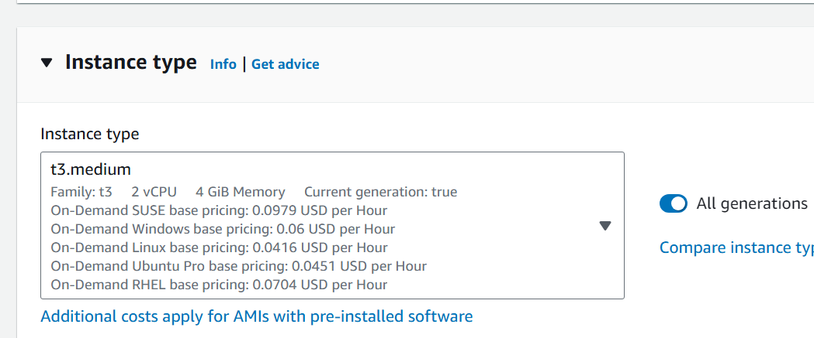

Create a new key pair
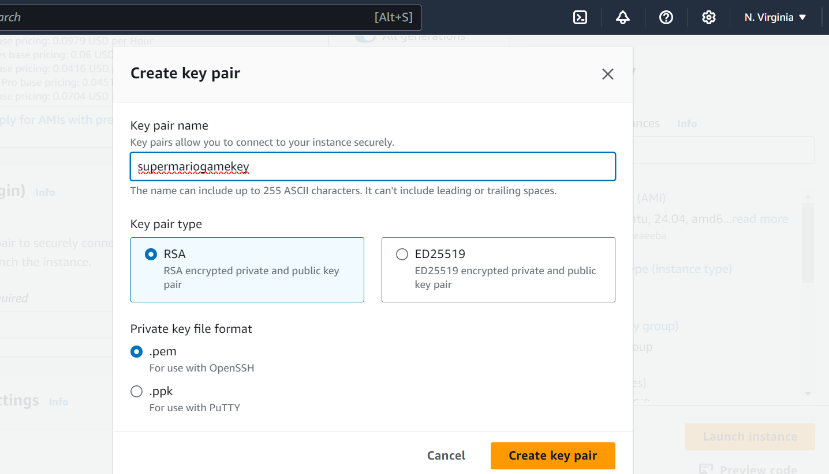

In security group allow ssh and http traffic

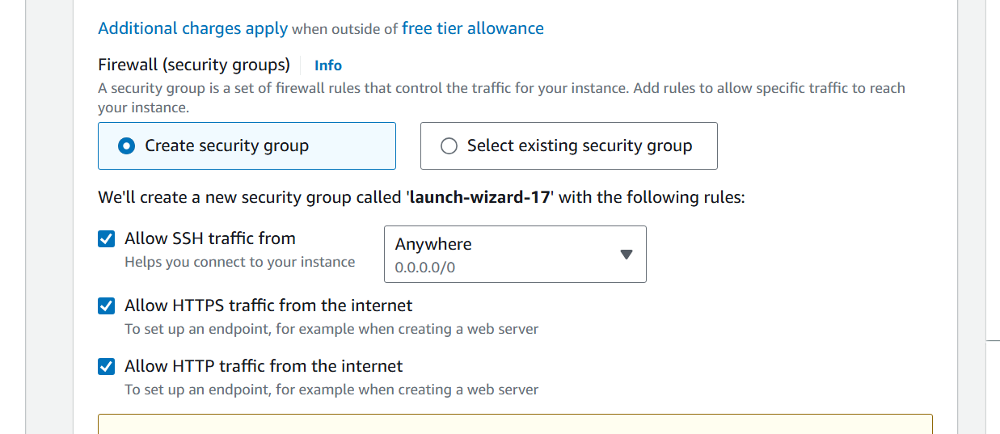

Go ahead and launch the instance

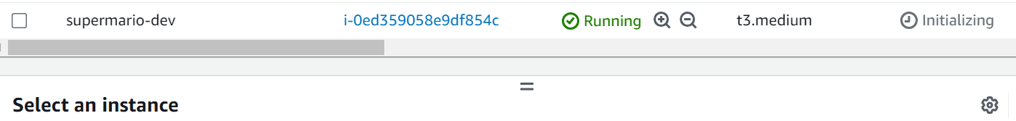

2) Now we will connect to the machine . For that we will first select the machine
And then click on connect button
Click on Ec2 instance connect tab
And click on connect button

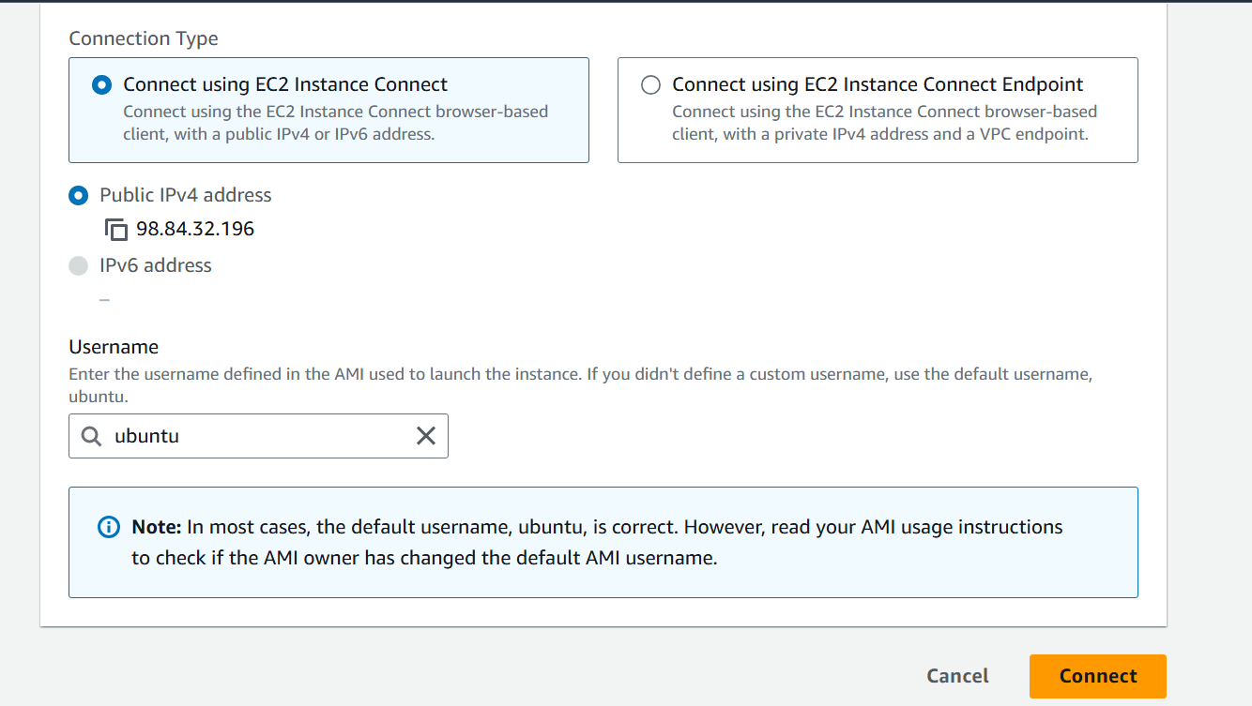

3) Run the following commands
a. sudo su
b. apt update
4) Setup Docker ,Terraform ,aws cli , and Kubectl
- apt install docker.io
2. usermod -aG docker $USER # Replace with your username e.g ‘ubuntu’ usermod -aG docker ubuntu
3. newgrp docker

5) We will now setup terraform in the machine
wget -O- https://apt.releases.hashicorp.com/gpg | sudo gpg --dearmor -o /usr/share/keyrings/hashicorp-archive-keyring.gpg
echo "deb [signed-by=/usr/share/keyrings/hashicorp-archive-keyring.gpg] https://apt.releases.hashicorp.com $(lsb_release -cs) main" | sudo tee /etc/apt/sources.list.d/hashicorp.list
sudo apt update && sudo apt install terraform
6) Now we will setup the AWS CL
curl "https://awscli.amazonaws.com/awscli-exe-linux-x86_64.zip" -o "awscliv2.zip"
apt install unzip -y
unzip awscliv2.zip
sudo ./aws/install
7) Now we will setup Kubectl
- sudo apt install curl -y
- curl -LO https://dl.k8s.io/release/$(curl -L -s https://dl.k8s.io/release/stable.txt)/bin/linux/amd64/kubectl
- sudo install -o root -g root -m 0755 kubectl /usr/local/bin/kubectl

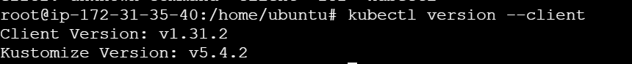

8) Every thing is setup and installed let’s make a IAM EC2 Role
Go to IAM -> Roles
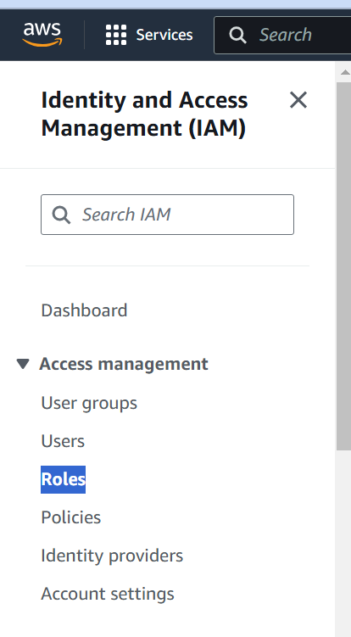
click on create role and choose EC2 from the dropdown
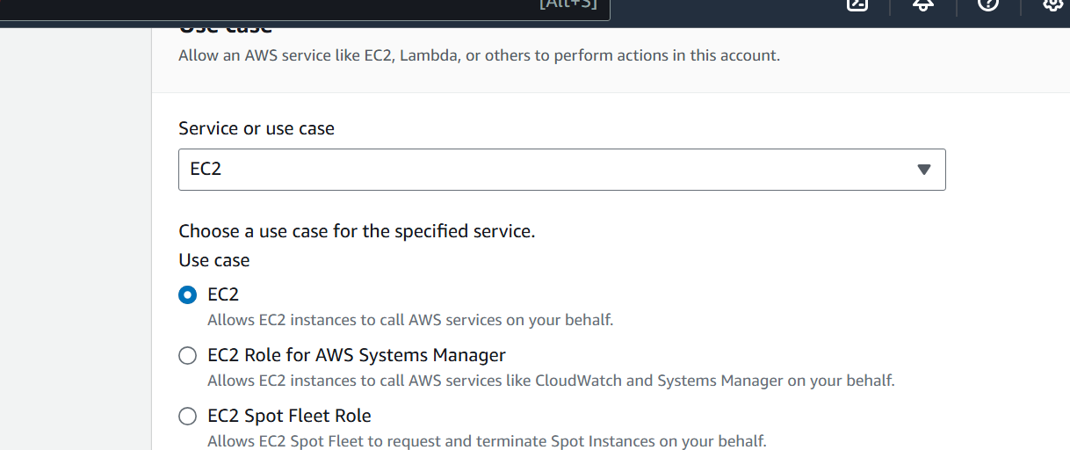

Choose administrator access

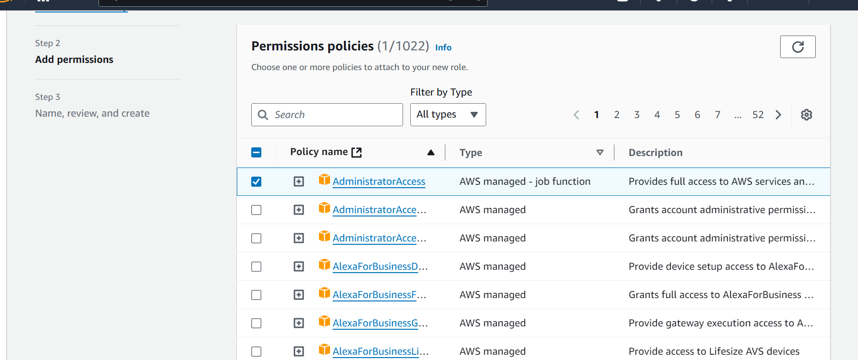

Next
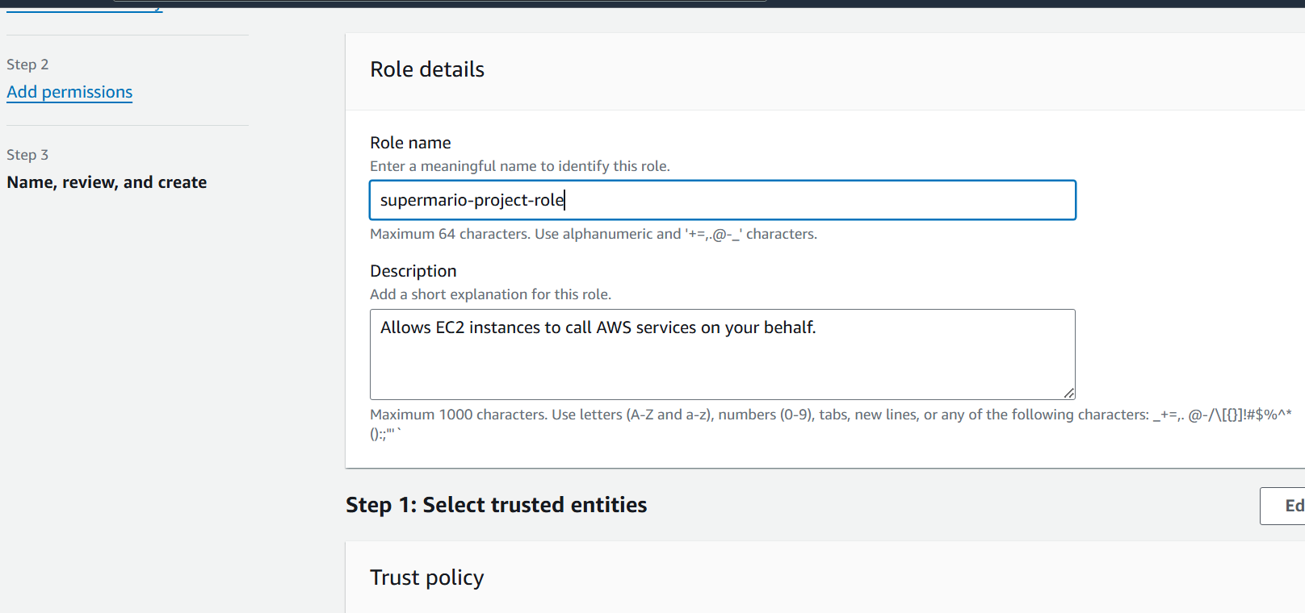

Click on Create role

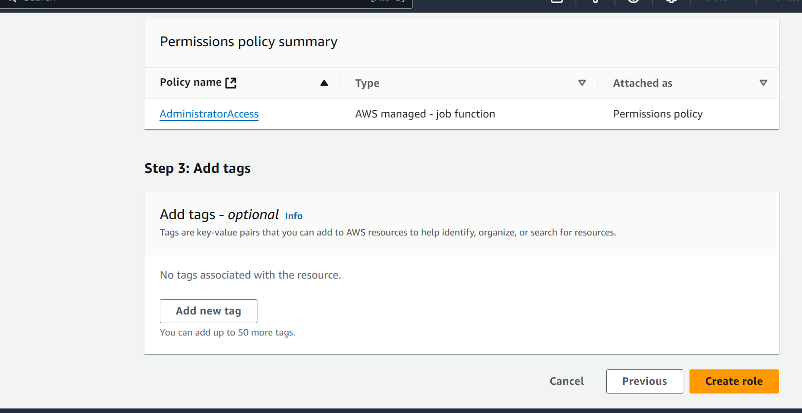

9) Now we will attach the IAM role to Ec2 machine
Go to ec2 machine and select the machine
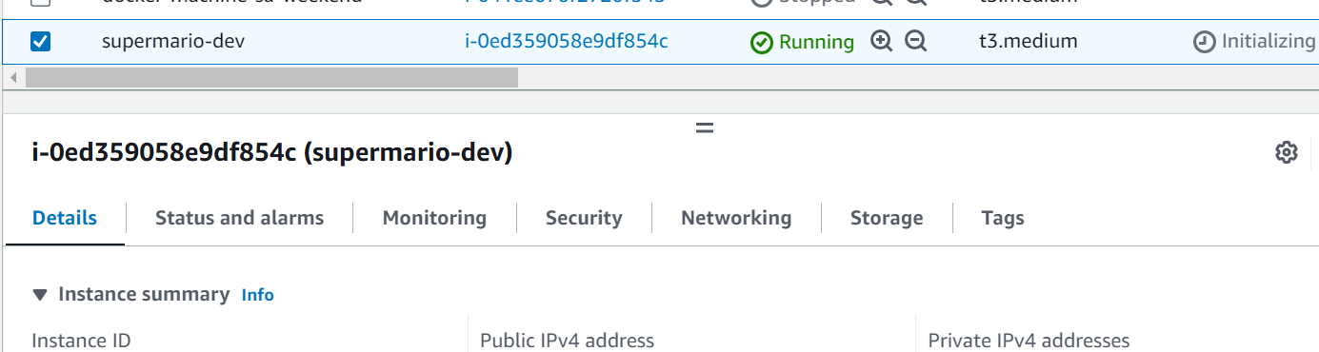

Right click on the machine

Click on Security -> modify IAM role

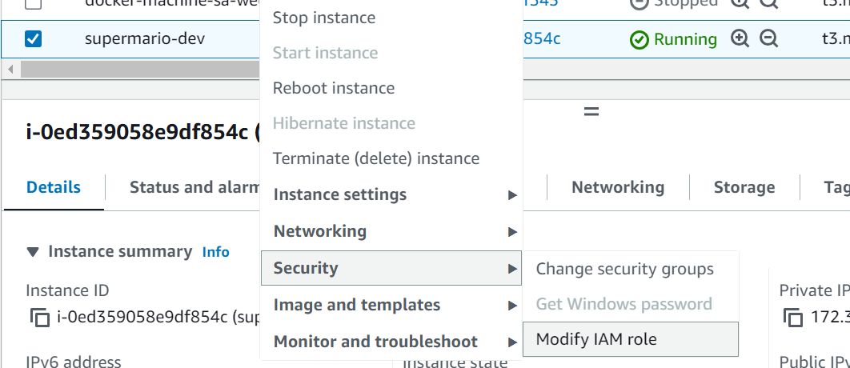

Select IAM role which we created previously
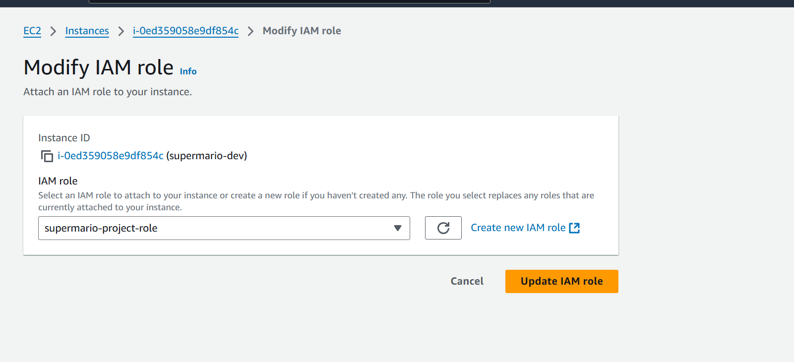

Click on update IAM role

10) Building Infrastructure Using terraform
First we will clone the github repo
Go to the machine
mkdir supermario
cd supermario
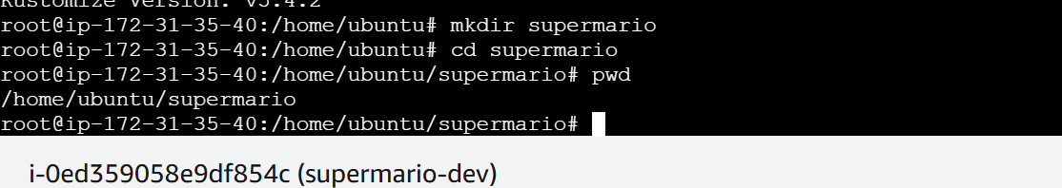

git clone https://github.com/akshu20791/supermario-game

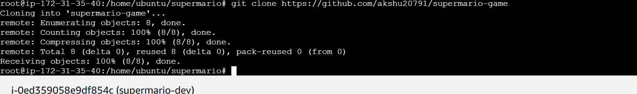

cd supermario-game

cd EKS-TF

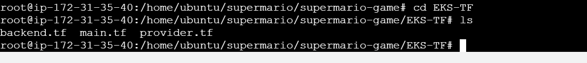
12) Go to aws -> S3 -> Create a s3 bucket with some unique name
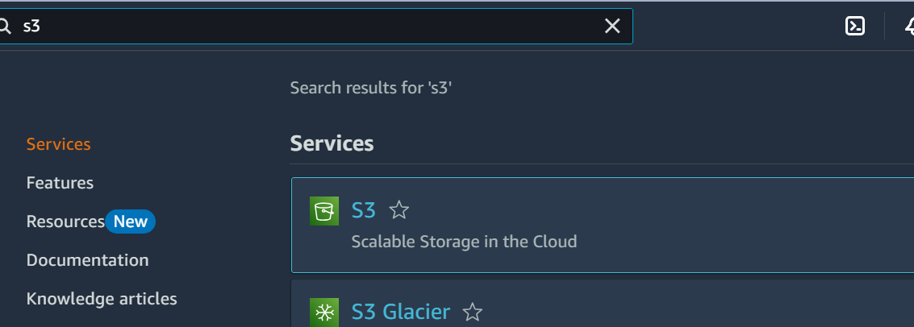

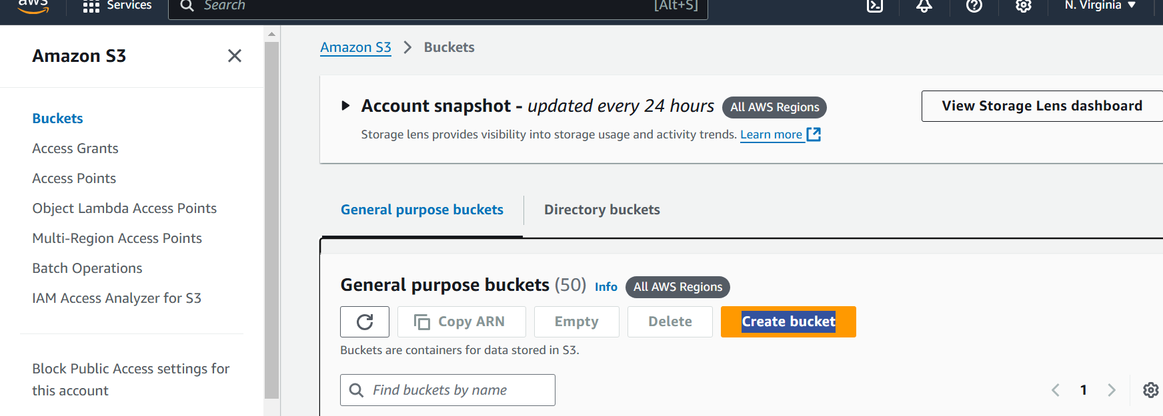

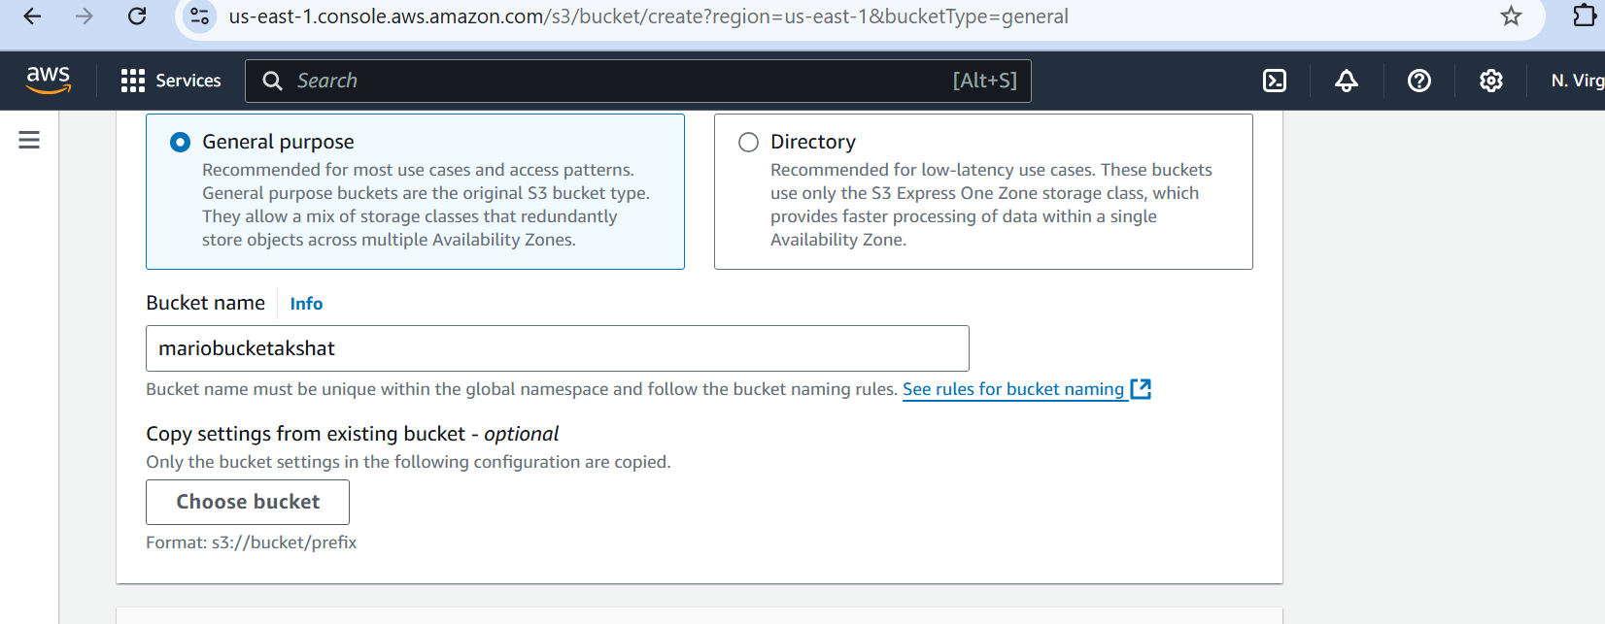

Create bucket
13) Go back to Ec2 machine
edit the backend.tf file by → vim backend.tf

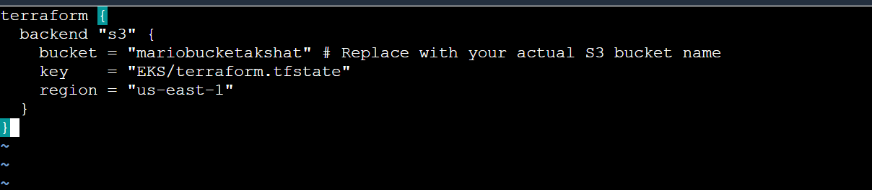

Note →make sure to provide your bucket and region name in this file otherwise it doesn’t work and IAM role is also associated with your ec2 which helps ec2 to use other services such S3 bucket

14) Now we will run

terraform init

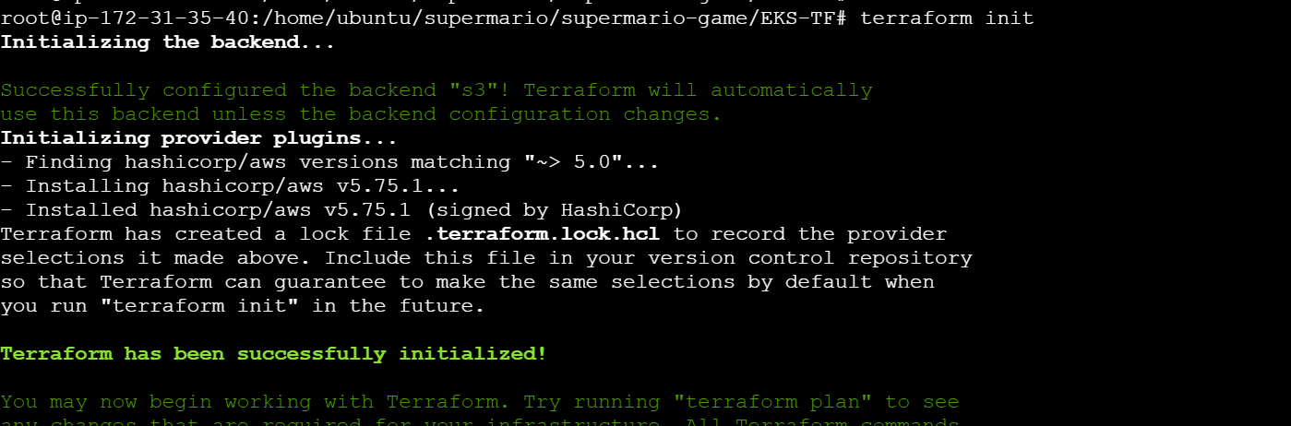

terraform validate

## go to AWS ACCOUNT -> GO TO VPC -> GO TO SUBNETS -> DELETE subnet in availability zone us-east-1e

terraform plan

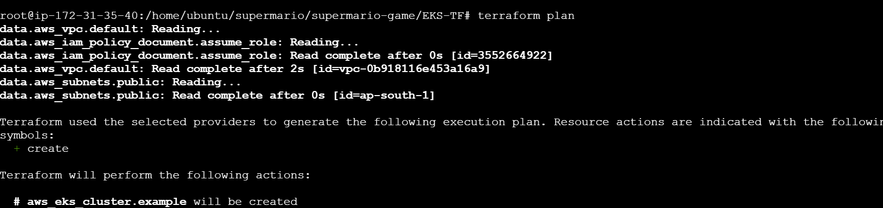

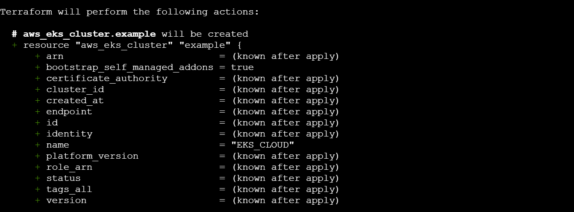

terraform apply --auto-approve

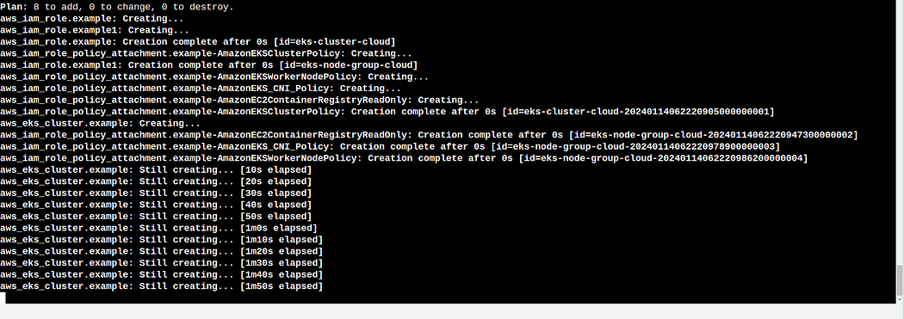

It will take 10-15 minutes to complete 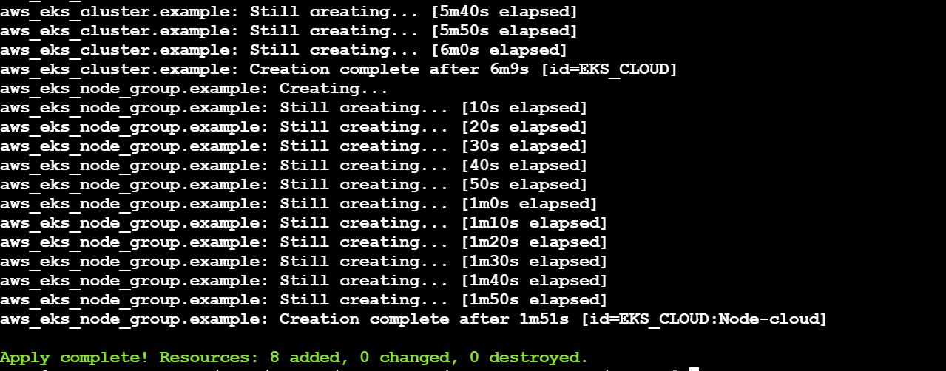

15) Now we will update the configuration of EKS
aws eks update-kubeconfig --name EKS_CLOUD --region us-east-1
# ensure that you take care of the region you are working in

16) Creation of deployment and service for EKS
- change the directory where deployment and service files are stored use the command → cd ..
- create the deployment
kubectl apply -f deployment.yaml

kubectl apply -f service.yaml

run → kubectl get all

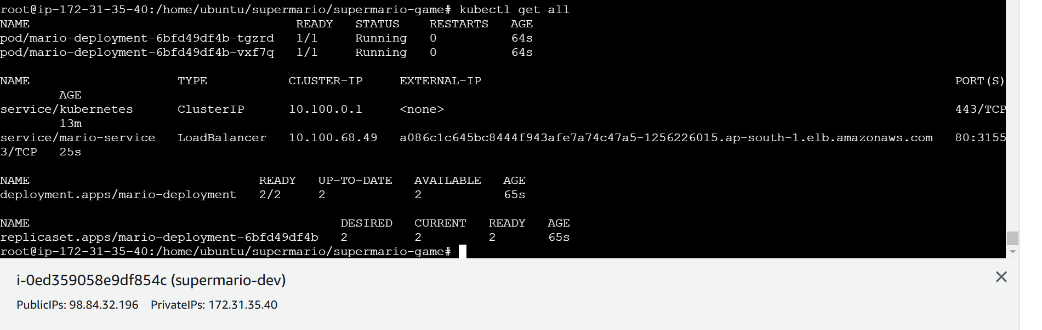

16) Now Run the follwing command to get the load balancer ingress
This command tells all the details of your application
kubectl describe service mario-service
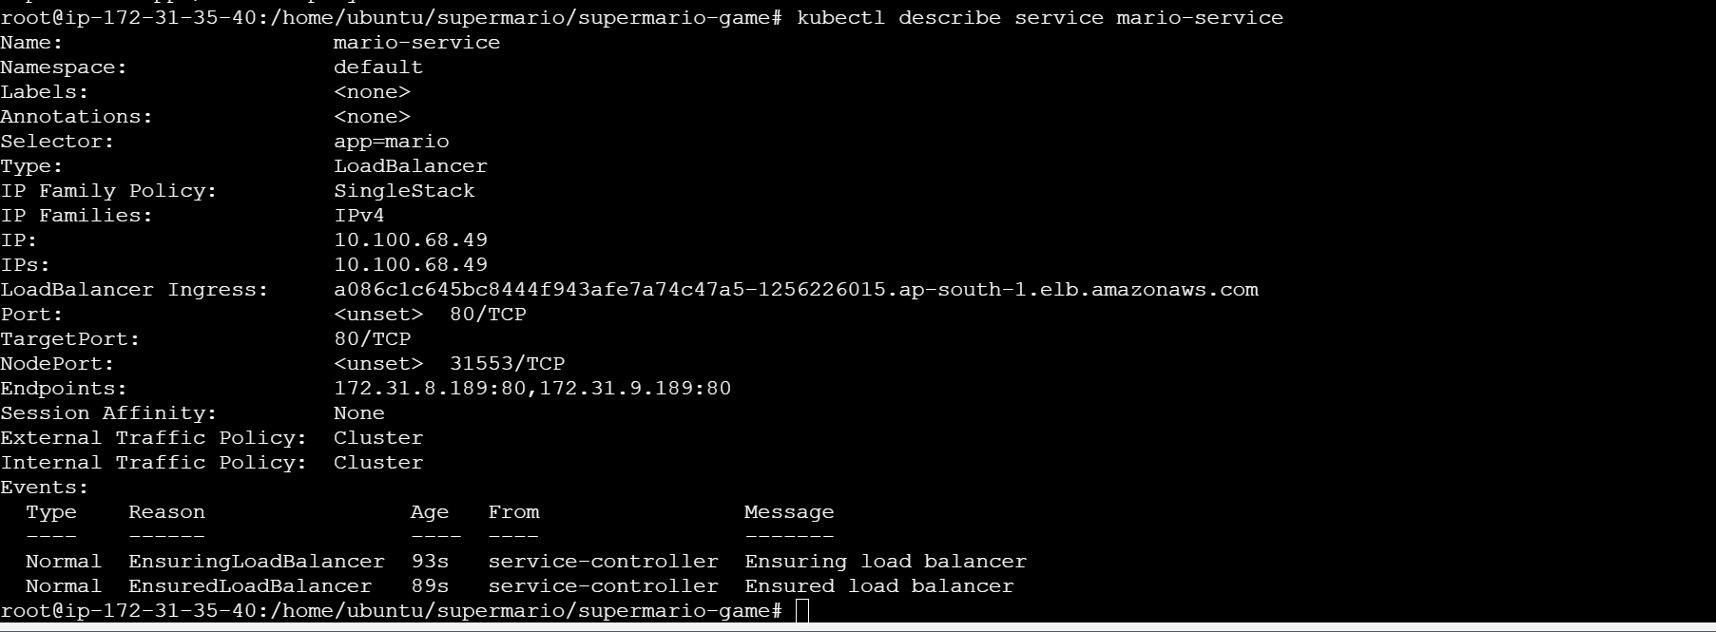
Here you will see load balancer ingress link
Copy that
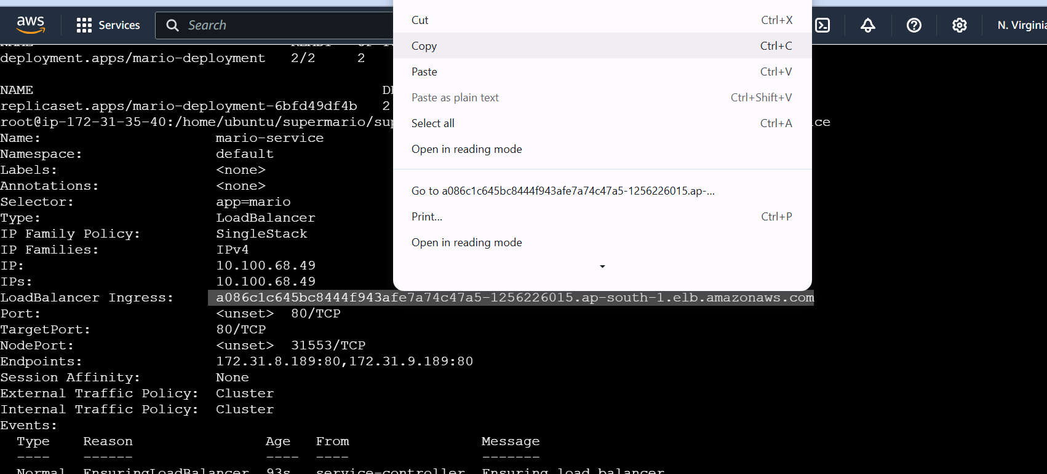

17) paste it in the browser
Ensure that when you copy paste …it should be http not https

